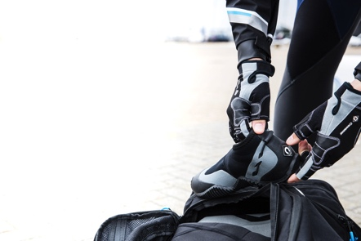
Release Date: 8th February 2018
RYA Suzuki Dinghy Show: 3rd – 4th March 2018
Crewsaver Stand: F11

Crewsaver to show NEW watersports range at the RYA Suzuki Dinghy Show 2018

Visitors to the RYA Suzuki Dinghy Show will be the first to be able to get their hands on Crewsaver’s new watersports range, which was launched to the trade at METStrade in November 2017. The new range, has a fresh new look and is packed full of nifty features and adventure-aiding essentials, including; performance clothing, accessories and luggage. The new range is aimed at all watersport enthusiasts and joins Crewsaver’s recently launched Atacama drysuits and Fusion 3D buoyancy aids.

As well as seeing the new 2018 range on the Crewsaver stand (F11) at the Show, visitors can take advantage of exclusive show giveaways AND enter the daily competition to WIN a full kit of performance gear from the 2018 collection (worth over £300, see more below). As always, the team will be on-hand to talk visitors through the range and answer any questions. Find a member of the team on the main Crewsaver stand or on one of the many Crewsaver retailers.

BREAKING NEWS! In the lead up to the show, Crewsaver will have a very special announcement to make. Aspiring athletes seeking sponsorship are encouraged to follow Crewsaver on Facebook, Twitter and Instagram to find out more!

Crewsaver performance clothing and equipment can be purchased at the show at a number of its retailers including;

- Andark Diving & Watersports – F6
- Force 4 Chandlery – B66
- Jimmy Green Marine D12
- Nucleus Watersports G25
- Pinnell & Bax – A10 & B48
- Welsh Harp - G38

The Crewsaver Dinghy Show Competition – WIN over £300 Worth of Performance Gear!
Join Crewsaver on stand F11 to pick up an entry card to WIN a full kit of performance gear from the 2018 collection (worth over £300). The prize includes the Crewsaver Spray Top, Pro 50N SZ Buoyancy Aid, Zip Boots, Three Finger Gloves, 10L Bute Drybag and a handy 75L Wet/Dry Holdall to put it all in. Entrants must return to the Crewsaver stand at 4pm to submit their entry cards for the daily live prize draw!*

The 2018 watersports range

Performance Clothing
Lightweight and compact, the Crewsaver Race Top is an unmissable addition for any watersport enthusiast, setting the bar for breathable performance thermals. Its waterproof fabric with a 10K hydrostatic head is fused with soft internal fleece lining providing the thermal protection needed to stay on the water for longer. Another benefit is the additional thermal protection offered by the foldable collar for optional face coverage. Junior RRP £68. Adult RRP £84

The Crewsaver Spray Top is the perfect solution for those seeking the next level in performance technology. The durable fabric has a hydrostatic head waterproof rating to 20K and is breathable up to 6K, making this one of the most advanced and affordable spray tops on the market. With uniquely tailored panels, the articulated shape of this spray top provides much sought-after unhindered freedom of movement. Junior RRP £77. Adult RRP £99

Gloves
Protection, warmth and dexterity. The Crewsaver glove collection provides everything needed to keep hands happy whilst on the water. With short finger, three finger and neoprene options available (all integrated with supple Amara palm protection) there is a style to suit, no matter what the demand. Gloves RRPs £19 - £26

Footwear
Choose from a wide range of styles and fabrics including a choice of 5mm or 3mm neoprene construction, zip entry vs slip-on and boot vs shoe. All designed from highly flexible and durable materials with easy donning in mind. Look out for the zip boot and ¾ boot, which feature reinforced panelling, perfect protection for hiking and trapezing. Footwear RRPs £17 - £55

Luggage
Built for adventure. The new luggage collection is practical, stylish and tough. Featuring traditional holdalls, drybags and wet/dry hybrids, these bags are truly life-proof. Luggage RRPs £18 - £60

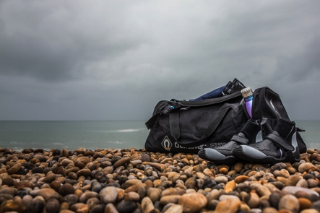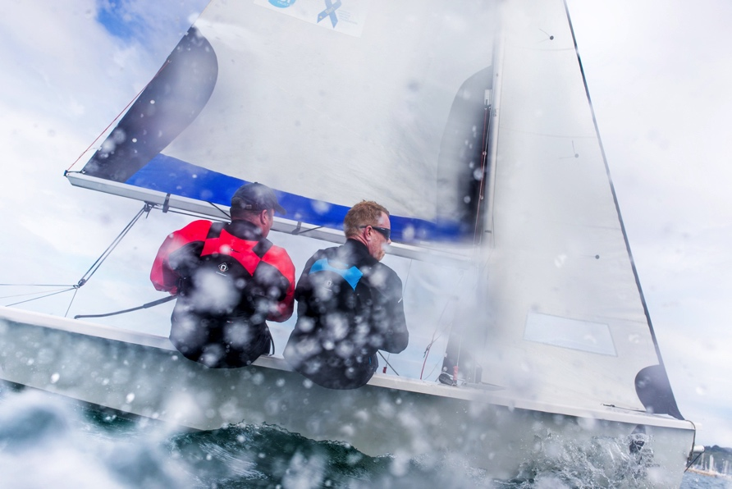

*T&Cs apply

//ENDS//

For media information, hi-res images or product tests please contact:

Crewsaver
Hazel Proudlock, Marketing Dept
T +44 (0) 1329 820406
E hazel.proudlock@survitecgroup.com

Alison Willis – Marine Advertising Agency Ltd
T +44 (0) 23 9252 2044
E Alison@marineadagency.com

Notes to Editors

Crewsaver is a world-leading manufacturer of marine safety equipment and clothing for the commercial and leisure marine industries. Based in Gosport, Hampshire, the company designs and manufactures bespoke safety equipment for several countries’ Special Forces, and the aviation and oil industries. Crewsaver is the only company to hold an exclusive contract to supply lifejackets to the UK government’s Environment Agency and the Royal National Lifeboat Institution (RNLI). They are part of the Survitec Group.

www.crewsaver.com

Survitec Group Survitec is a global leader in survival and safety solutions to the marine, defence, aviation and offshore markets. Survitec has over 3,000 employees worldwide covering 8 manufacturing facilities, 15 offshore support centres and over 70 owned service stations. It is further supported by a network of over 500 3rd party service stations and distributors. Across its 160-year history, Survitec Group has remained at the forefront of innovation, design and application engineering and is the trusted name when it comes to critical safety and survival solutions.

www.survitecgroup.com

