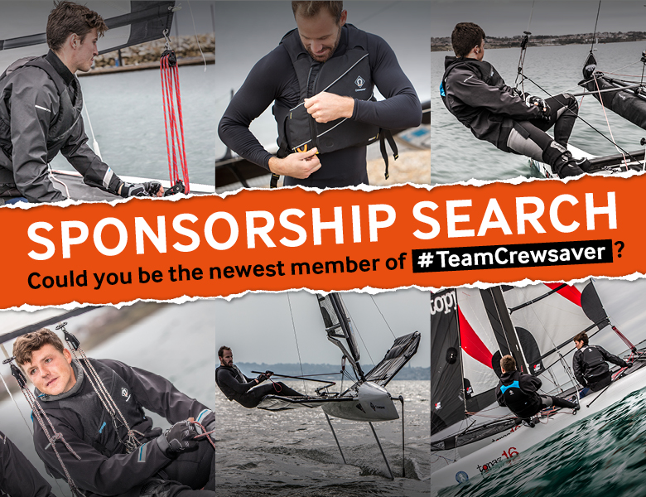
Release Date: 27th February 2018
RYA Dinghy Show 2018

Crewsaver announces an exciting sponsorship opportunity for aspiring sailors to celebrate the launch of its new watersports range.

As Crewsaver moves into its 61st year of designing and manufacturing performance and safety equipment, it has proudly announced the launch of its new watersports range and with it, a very exciting opportunity to join #TeamCrewsaver.

#TeamCrewsaver
Over the years, Crewsaver has been a proud sponsor of a variety of athletes, including offshore sailors, ocean rowers and junior dinghy sailors. All have had their own impressive array of skills, determination and flair for pushing the limits.

Crewsaver is seeking a talented and enthusiastic athlete with a passion for sailing to join #TeamCrewsaver. The successful applicant will join the likes of Alex Thomson, Phil Sharpe and Alain Sign as part of a 1-year sponsorship opportunity. In addition to a personalised website profile and social media coverage, Crewsaver will provide the successful applicant with performance and safety equipment from its new watersports and Fusion 3D buoyancy aid ranges.

“We understand the challenges faced by aspiring athletes to get a foot on the professional ladder and we hope that this opportunity can provide the boost someone needs to turn their passion for sailing into a career.” – David Duffin, Crewsaver Sales Director

How to enter
To apply for the Crewsaver sponsorship search, candidates should send their sailing CV to Crewsaver.marketing@survitecgroup.com. Application deadline is 31st May 2018, the winner will be announced via Crewsaver social media week commencing 4th June 2018. Good luck!

Join Crewsaver at the RYA Dinghy Show
Hopeful applicants will be able to catch up with the Crewsaver team at the RYA Dinghy Show (stand F11), where the new watersports range will also be available for the first time. The new range has a fresh new look and is packed full of nifty features and adventure-aiding essentials including performance clothing, accessories and luggage. The new range is aimed at all watersports enthusiasts and joins Crewsaver’s recently launched Atacama drysuits and Fusion 3D buoyancy aids.

//ENDS//

For media information, hi-res images or product tests please contact:

Crewsaver
Hazel Proudlock, Marketing Dept
T +44 (0) 1329 820406
E hazel.proudlock@survitecgroup.com

Alison Willis – Marine Advertising Agency Ltd
T +44 (0) 23 9252 2044
E Alison@marineadagency.com

Notes to Editors

Crewsaver is a world-leading manufacturer of marine safety equipment and clothing for the commercial and leisure marine industries. Based in Gosport, Hampshire, the company designs and manufactures bespoke safety equipment for several countries’ Special Forces, and the aviation and oil industries. Crewsaver is the only company to hold an exclusive contract to supply lifejackets to the UK government’s Environment Agency and the Royal National Lifeboat Institution (RNLI). They are part of the Survitec Group.

www.crewsaver.com

Survitec Group Survitec is a global leader in survival and safety solutions to the marine, defence, aviation and offshore markets. Survitec has over 3,000 employees worldwide covering 8 manufacturing facilities, 15 offshore support centres and over 70 owned service stations. It is further supported by a network of over 500 3rd party service stations and distributors. Across its 160-year history, Survitec Group has remained at the forefront of innovation, design and application engineering and is the trusted name when it comes to critical safety and survival solutions.

www.survitecgroup.com

