***Press release – Immediate release*****

Superyacht Tenders and Toys celebrates being ranked 45th in Sunday Times Lloyds SME Export Track 100
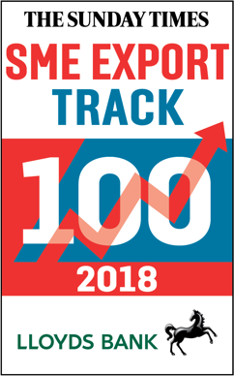
Superyacht Tenders and Toys (SYTT) is celebrating being ranked at 45 in the 4th annual Sunday Times Lloyds SME Export Track 100, published in The Sunday Times on 25th February 2018.

The Sunday Times Lloyds SME Export Track 100 ranks Britain’s 100 small and medium-sized companies with the fastest-growing international sales over the latest two years. It is compiled by Fast Track.

Ipswich-headquartered SYTT, which designs, manufactures and delivers yacht tenders and toys to superyachts globally, was founded in 2011 by former yacht manager Josh Richardson and his wife Claire. A large proportion of the company’s business comes from fitting out new build superyachts in Holland and Germany, as well as supplying superyachts owned by Middle Eastern royalty and international billionaires. International sales grew to £5.4m in 2017.

Josh Richardson said, ‘We are thrilled to have been ranked in the Sunday Times Lloyds SME Export 100. Being included is fantastic recognition for the work that our team has put in to grow the business, as we look to increase our international sales and expand into new markets.’

To learn more about Superyacht Tenders and Toys visit www.superyachttendersandtoys.com

ENDS
Media enquiries via Marine Advertising Agency:
Alison Willis, alison@marineadagency.com
Emma Stanbury, emma@marineadagency.com
T: 023 9252 2044
Or
Josh Richardson, Superyacht Tenders and Toys
T: UK +442380016363
T: France +33489733347
T: US +19643029066
E: info@sytt.co

Notes to Editors:
Superyacht Tenders and Toys is the leading independent consultancy and management company specialising in all superyacht tender and toy needs and provides practical solutions for the World’s finest yachts. Superyacht Tenders and Toys won the Queen’s Award for Enterprise: International Trade 2017, the most prestigious business award in the UK.

