Cupernham House, Cupernham Lane, Romsey, Hampshire SO51 7LF T +44 (0) 1794 521 111 F +44 (0) 1794 521 271
techsupport@westsysteminternational.com westsysteminternational.com

See WEST SYSTEM® Epoxy Products in action at the RYA Dinghy Show
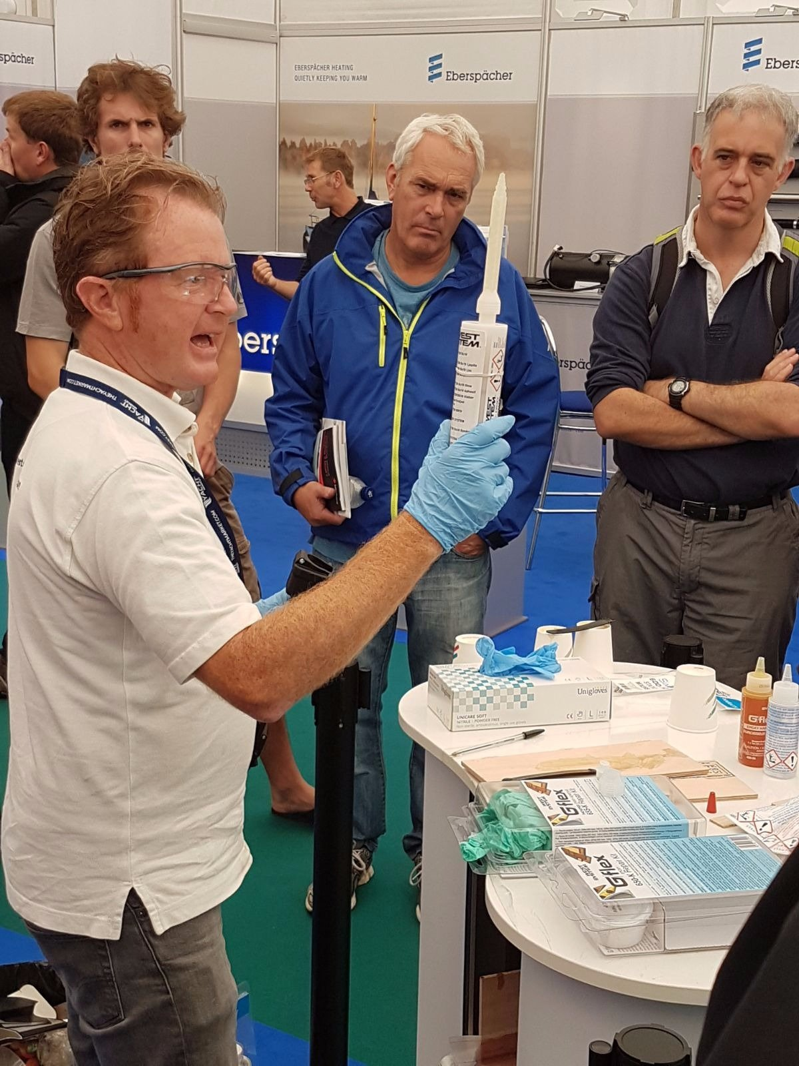
27th February 2018

The West System International (WSI) team will be running live demonstrations on its stand (C42, Great Hall) at the RYA Dinghy Show (3-4 March 2018) showing visitors how to get the most from its epoxy products.

Visitors to the stand can also enter a competition to win one of four WEST SYSTEM® 105-K Glass Fibre Boat Repair Kits. To enter visitors need to identify how many boats at the RYA Dinghy Show are made with WEST SYSTEM® or PRO-SET® epoxy products. They can do some research or make an educated guess then enter on the West System International stand (C42). At the end of the Show, the four closest entries will win a kit each. T&C apply, see full details at http://westsysteminternational.com/en/news/rya-dinghy-show-see-live-demos-of-west-system-products

At the Show, visitors can meet the friendly West System International team, pick up tips on dinghy repairs, ask for advice on using epoxy products and find out what products they should have with them in the dinghy park at race events to keep them on the water in the event of any dings! The live demonstrations will take place at 12:00 and 14:30 each day on stand C42.

WEST SYSTEM and PRO-SET products are market-leading and trusted by both professional boat builders and home project hobbyist’s worldwide.

West System International, manufactures WEST SYSTEM and PRO-SET epoxy products in the UK under license from Gougeon Brothers Inc., and distributes these leading brands across the whole of Europe, Africa and the Middle East via a well-respected distribution network.

ENDS
Notes to Editors:
West System International (a division of Wessex Resins and Adhesives) manufactures and provides international support for the world-renowned WEST SYSTEM and PRO-SET marine epoxy brands. Since Michigan boatbuilding brothers Meade, Joel and Jan Gougeon first experimented with the bonding power of epoxy over 50 years ago, the WEST SYSTEM® and PRO-SET® product ranges have become the epoxies of choice for private boat owners, boat manufacturers, chandlers and naval engineers throughout the world. West System International (WSI) has been working in partnership with Gougeon Brothers, Inc. for more than 36 years, manufacturing WEST SYSTEM and PRO-SET epoxies here in the UK. WEST SYSTEM and PRO-SET epoxy systems have a long-distinguished history that has earned a unique place at the heart of the worldwide epoxy user community. Whether you need an epoxy for laminating, bonding, coating, tooling or infusion, the combined breadth of WEST SYSTEM and PRO-SET products will provide the solution. Both ranges have passed extensive quality testing and are certified by Lloyds Register.
Media enquiries:
Marine Advertising Agency – Alison Willis, Alison@marineadagency.com 023 9252 2044
West System International – Hamish Cook, Hamish.cook@wessex-resins.com 01794 521 111

